Edward Venator

EECS 304 Lab 2

Problem 1

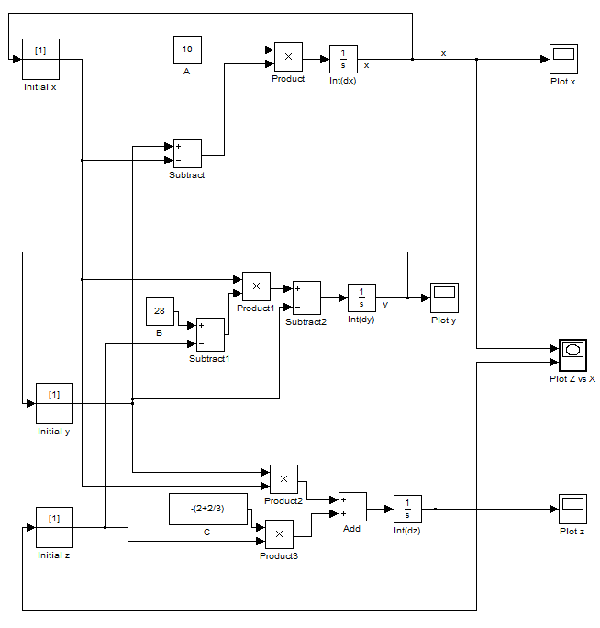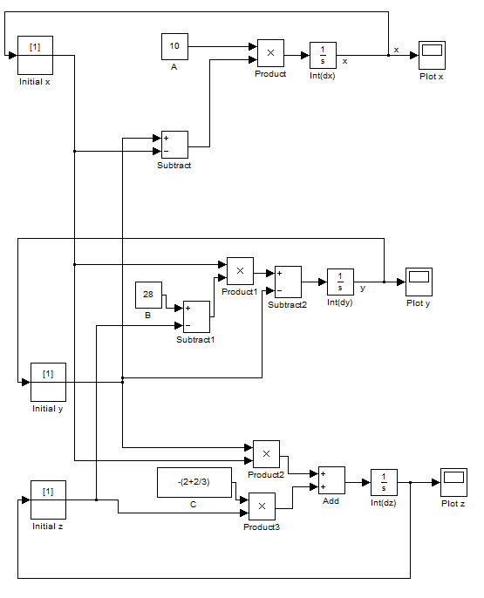

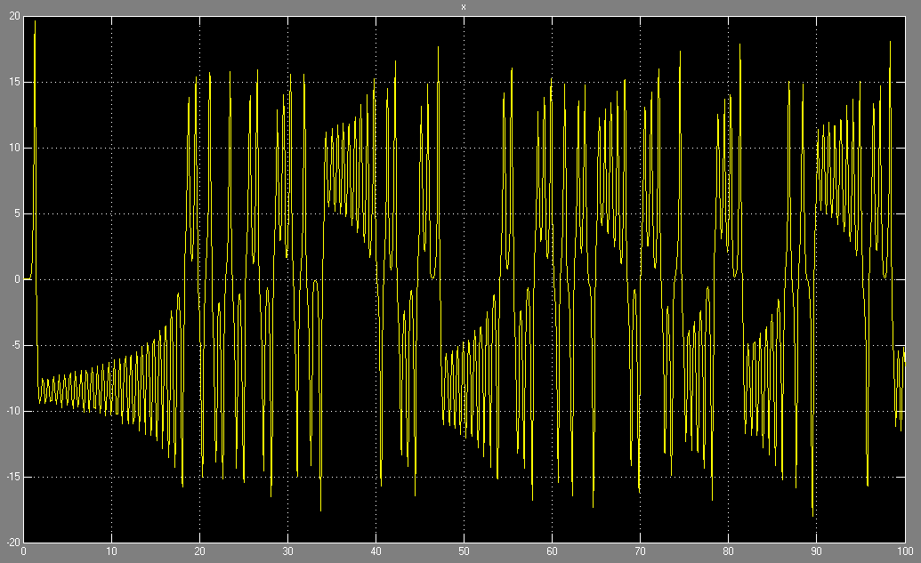

Plot of x over time (Initial conditions all = 1)

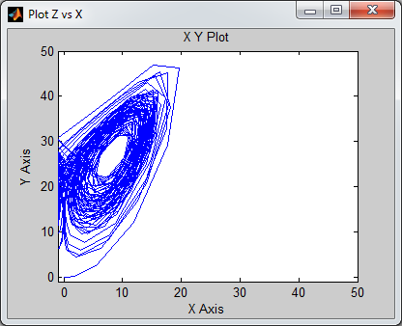

Problem 2

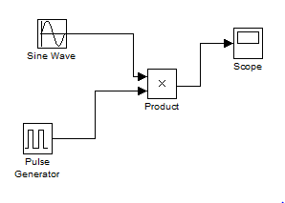

Sine wave frequency = 0.0104719755

Pulse Generator Period = 12

Pulse Generator Duty Cycle = 50%

